TABLE OF CONTENTS

1. INTRODUCTION 2

2. REFERENCE DOCUMENTS…………………………………………………………………………………………2

3. PLANT & MACHINERIES…… ……………………………………………………………………………2

4. work description …………………………………………………………………………………...2

5. Construction works  ……………………………………………………………………. 3

6. SEQUENCE OF CONSTRUCTION …………………………………………...9

7. HSE ………………..………………………………………………………………18

# 1. INTRODUCTION

This document consists of the details methodology and work plan of construction of 800m³ ground Sump And Pump room at Pothuhera.

Construction of 800m³ consist of pump room with following elements

* 25.3 x 8.325 meter C/C size rectangular reservoir with 400mm thick base slab & wall with 200mm thick roof slab. And adjacent 2.5x1.935 m, 1.2x1.23m size chambers.
* Construction of access manhole & air vent chamber.
* Fixing of inlet, outlet, over flow and washout DI pipes with DI valves
* Placing of Stainless steel (304) ladder inside the sump GI ladder in out side, aluminium chequered plate for the chambers cover.
* Landscaping of site including retaining wall (if necessary)
* 5.2 x 20.3 meter C/C size rectangular pump room.

# 2. REFERENCE DOCUMENTS

All related Contract Specification in the contract document shall be followed relevant to scope of work.

GFC Drawings, Approved Typical details etc.

# 3. PLANT & MACHINERIES

* Excavator / JCB
* Truck / Tipper
* Concrete Transit Mixer (From RMC Supplier)
* Mobile concrete Pump
* Water Bowser
* Levelling Instrument/Total Station
* Thermometers
* Slump cone and test mould
* Porker Vibrator
* Scaffolding / Staging Materials
* Rock driller with air compressor
* Water Pumps

**4.** **DESCRIPTION OF WORK**

The work described above shall consist of the of excavation, rebar work, formwork, in-situ concrete, fixing of pipe fittings and accessories, protective paint and backfilling & compaction. Other than that this method statement covers the assuring quality of construction, material and relevant safety measures adopted during construction.

**5. CONSTRUCTION WORKS**

**5.1. EARTH WORKS**

**5.1.1 Survey Works**

1. Initially Temporary Bench Mark (TBM) will be established in the Pothuhera reservoir site from fixed/known TBM which is allocated by the employer’s representative.
2. The professional surveyor shall be engaged to transfer the level datum and two primary mark will be established in Pothuhera site.
3. Two pillars will be constructed at the site to establish the levels and mark shall be coloured with red or yellow.

**5.1.2 Excavation Works**

**5.1.2.1 Excavation in the soft/hard soil**

1. The area to be excavated (2m beyond the structure) shall be cleared off all debris, bushes, logs, stumps and all objectionable material and disposed of as per the location finalized.
2. Trees having the girth less than 200mm will be removed by manually or machinery. And trees having girth more than 200mm will be removed by main contractor after obtaining the approval from the client.
3. As far as possible all excavation shall be carried out using mechanical excavators. Wherever, the excavation quantities are minimal or the limited space for mechanical excavation, manual excavation shall be carried out.
4. Preliminary excavation shall be carried out to a depth of 150 mm above the final level. Soft pockets / extra excavation shall be filled using excavated earth and compacted. In the case of removal of boulders the extra hole will be filled with sand and packed together by means of watering.
5. It shall always be ensured that the excavation is carried out to the true line alignment and levels conforming to the approved drawing. The final 150 mm of excavation with the tolerance of +/- 20 mm shall be carried out manually and just prior to pouring of PCC.
6. The excavated earth shall be stacked at a safe distance.
7. Any accumulation of water in the pit shall be dewatered without affecting other working areas and the slush underneath shall be cleaned before casting of PCC.
8. It shall be ensured that the minimum dimension required from criterion of providing formwork, safety and ease of working as defined in the safety manual are adhered to.

**5.1.2.2** **Excavation in the rock**

**5.1.2.2.1 Chemical Blasting****(If applicable)**

1. where ever the rock is fully exposed (outcrop) or partially exposed (to be removal portion), chemical blasting shall be adopted. Before start the blasting joint measurement shall be taken with client’s representative.
2. According to the position of the rock vertical drilling shall be done in the appropriate locations at required depth
3. After number of drilling the blasting chemical shall be filled compactly in each hole and top shall be tighten with timber pieces. Normally chemical shall be filled in the evening and if rain the area with number of holes will be covered by polythene.
4. After 12hrs the fragmented pieces shall be removed by excavator/JCB and stack or disposed at the adjacent sites.

**5.1.2.2.2 Controlled Blasting (If applicable)**

1. After receiving mining bureau approval via clients representative required materials shall be purchased through approved agent. Before starting the blasting joint measurement shall be taken with client’s representative.
2. Rock blasting expert shall be deployed for entire controlled blasting work
3. After removing of top soil necessary number of drilling shall be done by means of machines and blasting materials insert tightly with detonators. Top part of rock surface shall be covered with sand bags or thick layer of soil.
4. Before ignite the blast, all necessary safety precautions shall be taken according to WABAG safety procedures.
5. Fragmented particles shall be removed by excavator and the above procedures continues until reaching required level.
6. In-order to fine tune of bottom level less than 25mm of rock parts will be removed by manually with chisel and hammer.
7. If excavation level of the bottom is more than the required level the additional excavation shall be filled with PCC ( less than 50mm depth).
8. In the case of extra excavation due to the removal of boulders or removal of weathers rocks or fault rock, this additional excavation shall be filled with PCC at extra cost.

# 5.1.3. Backfilling Works

1. Back filling shall be carried out using selected excavated earth approved by the Engineer.
2. Backfilling earth shall be free from vegetable matter, rock particles and building materials.
3. Any loose material, protrusions, formwork components shall be cleared before commencement of backfill. The excess area between the natural ground and external wall faces shall be backfilled in layers not exceeding 200 mm after proper ramming using plate compactors, watering and consolidation. The final backfill surfaces shall be maintained to a proper profile and level as per the requirement. The compaction shall be tested (Achieve compaction not less than 95% MDD for each layer) as per contract specifications.
4. Since the stability of plinth protection and flooring/ basement depends on degree of compaction, most care should be undertaken.

**5.2. Shoring**

1. As per the site condition all related excavations are above the ground water level.
2. Shoring shall be provided if the excavation height exceeds 2m.
3. Shoring shall be done by driving vertical supports such as 3.9m height “ H” iron sections at selected intervals & carrying out trench excavation while placing wooden planks to support the ground. For additional bracing support will be provided by using GI props.
4. Until finish the all site works shoring continues and if protection wall replaced, the shoring will be discontinued.

# 5.3. REINFORCEMENT

1. Reinforcement bar shall be hot rolled weldable deformed steel bars confirming to BS standard.
2. The shop drawing with bar schedule shall be submitted to client representative for approval prior to bending of reinforcement. Bar bending schedule shall incorporate the bar lengths, hook sizes, overlap lengths, spacer bars, bar diameter, crank spacing etc.
3. Reinforcement shall be accurately fabricated to the dimensions indicated in the drawings. The cutting and bending of reinforcement bars will be carried out using a cutting/ bending machine or manually and as per the bar bending schedules.
4. Before being placed in position reinforcement shall be thoroughly cleaned of rust, dirt, grease, paint or other coatings.
5. The erected reinforcement shall be secured with iron wire ties at inter section against displacement
6. Sufficient number of cover blocks and stools shall be provided to hold the position of the reinforcement.
7. After the erection of reinforcement approval will be obtained from client to erect the formwork.
8. Appropriate Concrete cover shall be maintained between reinforcement and face of concrete.
9. The straightening and re-bending of an incorrectly bent bar shall be avoided. The straightening of the dowels wherever applicable shall be undertaken with proper care.
10. The reinforcement shall be placed as per the approved construction drawings and bar bending schedules given due consideration to the cover blocks, binding wires, chairs, curtailment, correctness of tolerances, hook specifications etc.
11. The inserts, conduits, sleeves, anchors, opening etc. shall be suitably provided by welding / binding wire.
12. Under certain circumstances if necessary Re-baring of reinforcement will be adopted. The chemical anchoring will done for anchoring purposes.

# 5.4. FORMWORKS

1. The size of members of frame and support shall be adequately selected.
2. Formwork design details along with relevant shop drawings need to be submitted client representative approval. 2x4 timber and the 18mm coated plywood with vertical support of light weight ‘H’ beam will be used for the form work.
3. The formwork shall be designed to withstand lateral thrust and weight of fresh concrete during vibration without distortion, leakage, cracking, failure and buckling.
4. The shutters shall be erected in proper line and level and shall be cross checked before put to implementation. Any old concrete droppings, protrusions, wooden dust, etc., before concreting shall be cleared off and the same shall be cleaned before installation.
5. The faces of formwork in direct contact with concrete shall be applied with a coat of approved mould oil.
6. All leakages, bulging, sagging, twisting and warping of formworks shall be avoided. However, in case of leakages, if any, tightening wedges adjustment by jacking and then approved methods shall be adopted before initial set of concrete.
7. The joints between each form work set shall be firmly sealed by sponge slips and masking tapes in order to prevent the grout leakage.

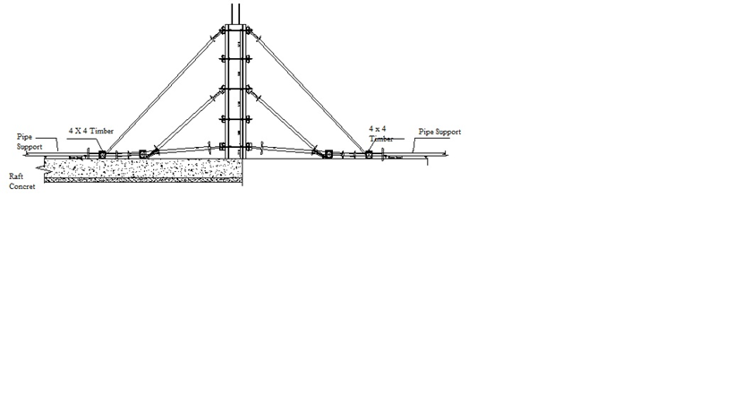

**Typical arrangement for column form work**

**5.5. STAGING /SCAFFOLDING**

1. Scaffolding shall be adequately planned to cover the area of shuttering and to withstand the dead loads wherever applicable.
2. The vertical posts shall not be generally allowed to rest on the ground directly. The base plates of suitable thickness shall be provided below the props. Wherever the area of shuttering details limits the provision of base plates, the same shall be allowed to rest on hard and compacted ground.
3. For all working platforms erected at any height greater than 6.0 m, two number working platforms shall be erected as an additional safety measure. Suitable temporary handrails shall be provided on all edges of working platform.
4. The staging shall be braced with diagonals, ropes, shears bracers as applicable to provide lateral stability against overturning and side thrust due to impact load, wind load, etc.
5. Safety tags to be attached on the staging/ scaffoldings by the Safety officer. To be used only after safety tagging.
6. Working platform should be much as far it can withstand the load of the number of workers working at the same time with necessary equipment like vibrates ,finishing tools, arms, tackles etc. and ease to inspect also.

# 5.6. CONCRETING

1. Concrete shall be outsourced from approved RMC supplier and grade of concrete should be approved upon trial mix test and confirmation by client representative.
2. Ready Mix Concrete will be transported to site by Transit Mixers(TM) from the approved supplier.
3. All tests shall be conducted as per the relevant BS 1881codes of practice for fresh & hardened concrete.
4. Slump test shall be performed at Batching plant site and immediately before placing.
5. Adequate number of 15 cm x 15 cm x 15 cm concrete cubes shall be tested for 7 to 28 days strength in the site laboratory and report shall be submitted to employer’s representative for approval.
6. Relevant 7 days and 28 days test reports shall be submitted and maintained at site after approval for ready reference and check.
7. The pour card for reinforced concrete activity shall be filled at site and countersigned for approval by the Employer’s representative before commencement of pour.
8. All checks for major concreting shall be done on the preceding day of concrete.
9. All raw materials, adequate manpower and relevant plant and machinery shall be kept ready for any exigency / emergency during concrete pour.
10. The concrete shall be poured within initial setting time of cement. It shall be ensured that initial set / segregation of concrete is avoided under all circumstances during transfer and placing.
11. The vertical drop chutes / elephant trunks shall be used to pour concrete at lower levels when the drop of concrete exceeds 1.5 m to avoid segregation
12. The immersion type needle vibrator size 60/40/20 shall be applied for compaction of concrete symmetrically to cover all areas immediately after placing of concrete. The vibrator needle shall penetrate vertically and vibration shall continue till concrete flattens, rising of air bubbles is terminated, concrete takes a glistening appearance and aggregates blend with the surface. The vibrator shall be withdrawn slowly so that the holes are not created during its removal.
13. The concrete surface shall be smoothened with a wooden float or a trowel with pressure to give a finish similar to that of the rubbed down shuttered faces. The finish shall be continued till the concrete reaches its initial set.
14. It shall be ensured that all structural insert plates, base plates, puddle, pipe fittings, bolts etc. are adequately and suitably anchored as per the approved construction drawings before commencement of concrete.
15. In order to expedite and to facilitate the progress, opening of suitable size shall be provided as a provision for installing puddles etc. in future. After the puddles under this provision have been installed, the openings shall be grouted with concrete/ non-shrinking material as required to ensure the watertight structure.
16. PCC shall be cast as per the required thickness with smooth finish and 1000 gauge polythene will be laid on top of the blinding concrete.
17. During hot weather to prevent the cracking or crazing of concrete shall arrange for concrete to be placed in the early morning or late evening as directed by the Engineer.
18. Concreting will not be permitted during heavy rain or when the concrete temperature rises above 32oC.

# 5.7. CURING

1. Curing shall be carried out using approved water source.
2. Curing shall be carried out based on the procedures given below. One or more of the prescribed methods shall be adopted based on the site requirements.
3. Moist Gunny Bags

When continuous water spray is not possible due to various obstructions, work in progress in close proximity and heights, it is proposed to cover fresh concrete either by gunny bags or hessian cloth and these shall be kept moist by spraying water for not less than 10 days.

1. Ponding

Usually ponding shall be employed over slabs and rafts or where large area of structure is exposed horizontally.

**6. SEQUENCE OF CONSTRUCTION**

**Excavation**

1. The ground area shall be scrapped and cleared off all the debris and approximate uniform ground level shall be attained.
2. Surveyor has to outline the structural area with NWSDB/Wabag, the required lines/edge of the structure shall be fixed using Theodolite/ Total station. The edge distance of foundation centre shall be located on the ground at four corners. The corners shall be diagonally checked to ensure the correct layout of the structure.
3. The centre line, foundation edge & footing locations of the structure shall be denoted on the ground by means of pegs at uniform distance following with white mark.
4. The excavation shall be carried out using mechanical or manual methods based on the quantity of earthwork and the working area. During excavation necessary slops should be kept as per the issued drawings.
5. Base formation levels are 141.30 for Pump room and 142.05 for sump area ( except screed ). Final required level will be excavated by manual. Screed concrete will processing after NWSDB/Wabag approval.

**Blinding Concrete Gr 15**

1. The PCC shall be laid as per the level indicated in the approved drawings so that the level of the top of PCC shall be 141.30 for Pump room , 142.05 for sump area and 141.30 for catch pit at pump room.
2. The layout, as detailed above shall be carried out on the PCC surface for wall foundation and the wall thickness to identify the correct position of the wall and footings.

**Raft & Footing Concrete**

1. Reservoir & chamber raft outer lines should be marked on screed top by the surveyor and that should be approved by NWSDB/Wabag. Block wall shall be erected raft outer faces to the height of about **400**mm & 150 mm height ply form for reservoir wall kicker. As shown in Fig. 01

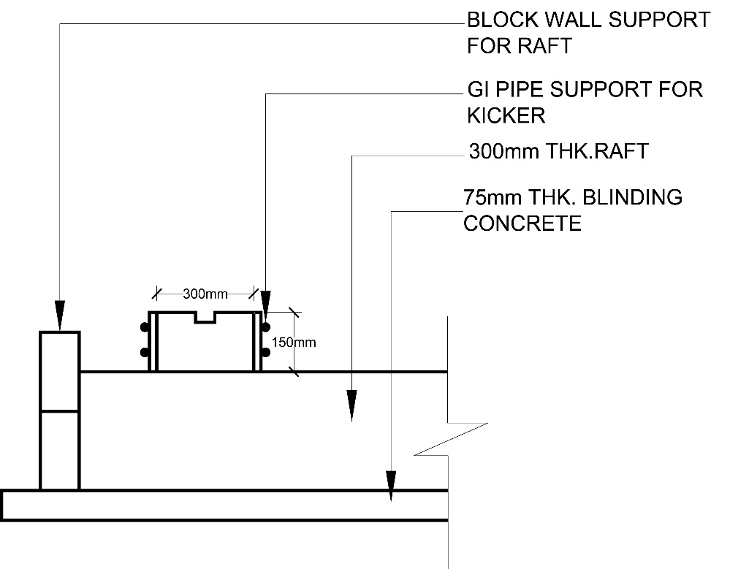

Fig. 01

1. Raft, columns & walls reinforcement shall be placed as per the approved drawing and bar schedule. All intersections of bars shall be secured with gauge 18 soft iron wire, the ends being turned into the body of the concrete. In the raft, cover shall in earth face **75** mm and same as from top face **50**mm.
2. C35A grade concrete should be poured to raft , starting bottom most level of the raft & wall kicker using mobile concrete pump, after the approval of reinforcement, formwork, left openings for inlet/outlet pipes at the level of 141.833(600mm dia) & 142.210(200mm dia. 3nos) & 142.273 (150mm dia. 6nos) and Over Flow /Drain pipes at the level of 142.635 (600mm dia.) / 141.7 (250mm dia. 2 nos) wall opening to be left for DI puddle pipes placing as per the drawings.
3. While concerting pouring temperature to be maintained below 32 C , minimum 06 nos. of concrete cubes to be casted every 20m3 for 7 & 28 days testing. After completion of concrete works & levelling, 50 * 50 mm size rectangular type wood bras should be inserted by hand from top of freshly casted wall kicker. Then 1 or 1.5 hrs later inserted 50 * 50 mm wood bars should be removed lifting up by hand to make a key and green cutting to be done on kicker / wall joint by high pressure water jet when concrete top got enough stiffness.

After concreting curing should be carried out by water ponding 7 days from next day on wards.

The concrete for the base raft is poured in sections, which are of a convenient size and volume

to enable construction to be finished in the time available. The pouring pattern including volume and time

taken for pouring are shown in the Fig. 02 & Fig. 03

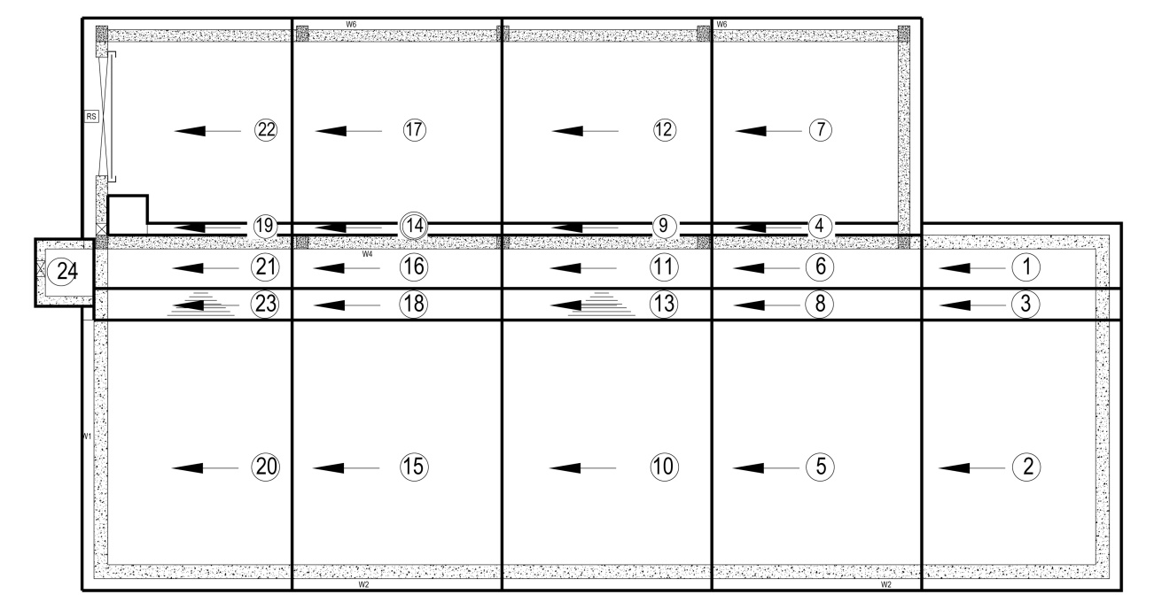

Fig. 02 Concrete Pouring Pattern

|  |  |  |  |  |
| --- | --- | --- | --- | --- |
| Truck No. | Volume (m3) | Batching Time | Arrival at Site | Concrete Finish Time |
| 01. | 5 | 06.30 | 07.15 | 07.45 |
| 02. | 5 | 07.00 | 07.45 | 08.15 |
| 03. | 5 | 07.30 | 08.15 | 08.45 |
| 04. | 5 | 08.00 | 08.45 | 09.15 |
| 05. | 5 | 08.30 | 09.15 | 09.45 |
| 01. | 5 | 09.00 | 09.45 | 10.15 |
| 02 | 5 | 09.30 | 10.15 | 10.45 |
| 03 | 5 | 10.00 | 10.45 | 11.15 |
| 04 | 5 | 10.30 | 11.15 | 11.45 |
| 05 | 5 | 11.00 | 11.45 | 12.15 |
| 01 | 5 | 11.30 | 12.15 | 12.45 |
| 02 | 5 | 12.00 | 12.45 | 13.15 |
| 03 | 5 | 12.30 | 13.15 | 13.45 |
| 04 | 5 | 13.00 | 13.45 | 14.15 |
| 05 | 5 | 13.30 | 14.15 | 14.45 |
| 01 | 5 | 14.00 | 14.45 | 15.15 |
| 02 | 5 | 14.30 | 15.15 | 15.45 |
| 03 | 5 | 15.00 | 15.45 | 16.15 |
| 04 | 5 | 15.30 | 16.15 | 16.45 |
| 05 | 5 | 16.00 | 16.45 | 17.15 |
| 01 | 5 | 16.30 | 17.15 | 17.45 |
| 02 | 5 | 17.00 | 17.45 | 18.15 |
| 03 | 5 | 17.30 | 18.15 | 18.45 |
| 04 | 5 | 18.00 | 18.45 | 19.15 |
| 05 | 5 | 18.30 | 19.15 | 19.45 |
| 01 | 5 | 19.00 | 19.45 | 20.15 |
| 02 | 5 | 19.30 | 20.15 | 20.45 |
| 03 | 5 | 20.00 | 20.45 | 21.15 |
| 04 | 5 | 20.30 | 21.15 | 21.45 |
| 05 | 5 | 21.00 | 21.45 | 22.15 |
| 01 | 5 | 21.30 | 22.15 | 22.45 |
| 02 | 5 | 22.00 | 22.45 | 23.15 |
| 03 | 5 | 22.30 | 23.15 | 23.45 |
| 04 | 3.30 | 23.00 | 23.45 | 24.15 |

Fig. 03 Concrete volume & Time Schedule

1. ~~14 Nos column footings to be outlined on screed top by surveyor and that should be verified with NWSDB/Wabag. Footing & column reinforcement should be erected as per the bar schedule leaving 75 mm cover for the earth contact faces. Obtaining the approvals for reinforcement /form work by NWSDB/Wabag grade C35A concrete to be poured. Cubes making and curing as the details given in No. 11 above. And Footings concrete top level to be 74.000.~~

**Columns Concrete**

1. 5 Nos C3 columns should be casted from 144.45 up to 149.00, As shown in Fig. 04 . After the approvals for the reinforcement/formwork by NWSDB/Wabag grade C35A concreting to be carried out and follow the guideline for concrete cube casting & curing as in No.11. Simultaneously , cable trench reinforcement to be erected on outlined screed top and after the necessary approvals grade C35A concrete to be done.

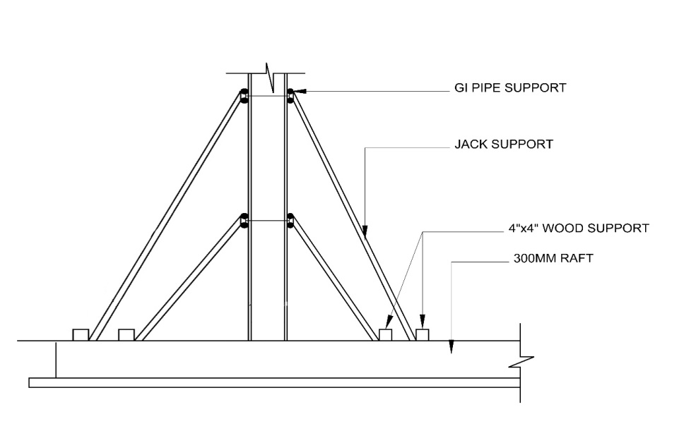

Fig. 04

**Columns / Walls concrete**

1. Reservoir walls & columns reinforcement to be done leaving necessary horizontal bars for ground beams/adjacent walls. The approval of reinforcement, cleaning of wall kicker top , inserted DI puddles , SS & MS plates as per the drawings , wall forms to be done to a line & plumb keeping 40 mm cover blocks as shown in Fig. 05.

GL

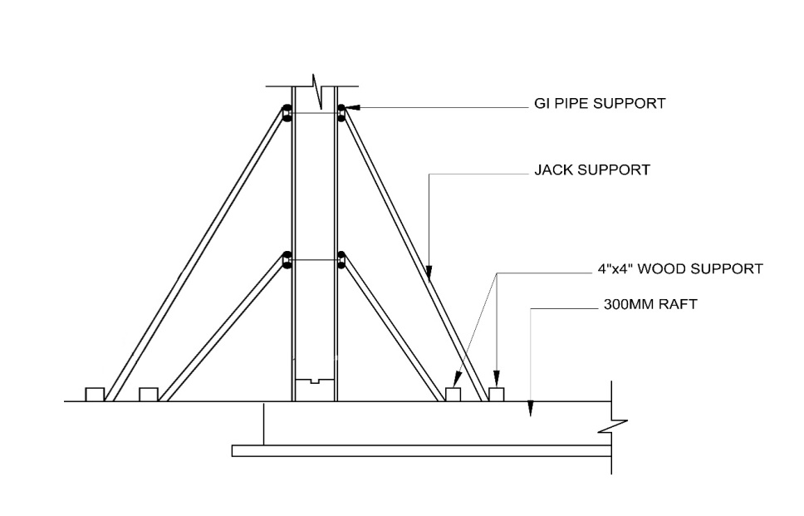

GL

Fig. 05

1. The wall reinforcement shall be erected in correct spacing as per the approved drawing and shall be placed vertical to the plumb as far as possible. The spacing of the reinforcement shall be checked before concreting. Vertical bars shall be supported properly during foundation concreting and further works.
2. Inner wall shutters of height 2.1m shall be then positioned side of the kicker and appropriate inner supports will be placed. After cleaning of particles in the existing wall outer shutter will be continued and both shutters properly tightened with combination of ‘P’ cones and tie rods. Wall shutters shall be erected to plumb and wall width of 300mm maintained.
3. The foam of required thickness shall be provided in between the adjoining shutters and along the wall face to prevent the leakage of the slurry. All subsequent lifts of the walls shall be cast using adequate staging, platform, and alignment and placing the shutters as discussed above. In case of any leakage of slurry, the same shall be washed off with jet of water to prevent the setting of concrete on the wall surface.
4. In each wall section the depth of each pour shall be 800mm and subsequently follow with next section of form work for same height.
5. And as well as SS rungs should be placed in chamber walls as shown in drawings before the concrete works.
6. C35A grade of concrete to be poured up to about 1m height right round the reservoir. During concreting needle vibrating porker should be applied properly. And the same way , next pouring layer to be carried out to the required level. Follow the guideline for concrete cube casting & curing as in No.9. Curing of structure shall be carried by moist gunny bags as specified in the item no 16 and casting date will be marked in paint to ensure curing is done up to the required period of time.
7. After pouring green cut will be performed as per describe in the item No 11.
8. Balance height of reservoir wall shall be casted up to the varies levels with the wall as shown in the GFC drawing sections 6,7,8,9,10,11,12,13,14 & 15
9. Soil back filling to be done proper compacting outside the structure layer by layer.
10. The surface of the P-Cone holes shall be well cleaned for dry pack mortar to free from dust and other loose material. On the saturated surface construction grout(non- shrinkage) shall be applied as per the manufactures specification. Then the repaired surface will be cured for 24 Hrs.

**Slab Concreting**

1. Walls / columns tops shall be levelled to 146.8. And Required height of props with horizontal support shall be placed in & out sides with adjustable pipe supports at 1500mm interval to support the timber frame. On the timber frame 18” thick plywood will be spearheaded firmly as shown in Fig.06

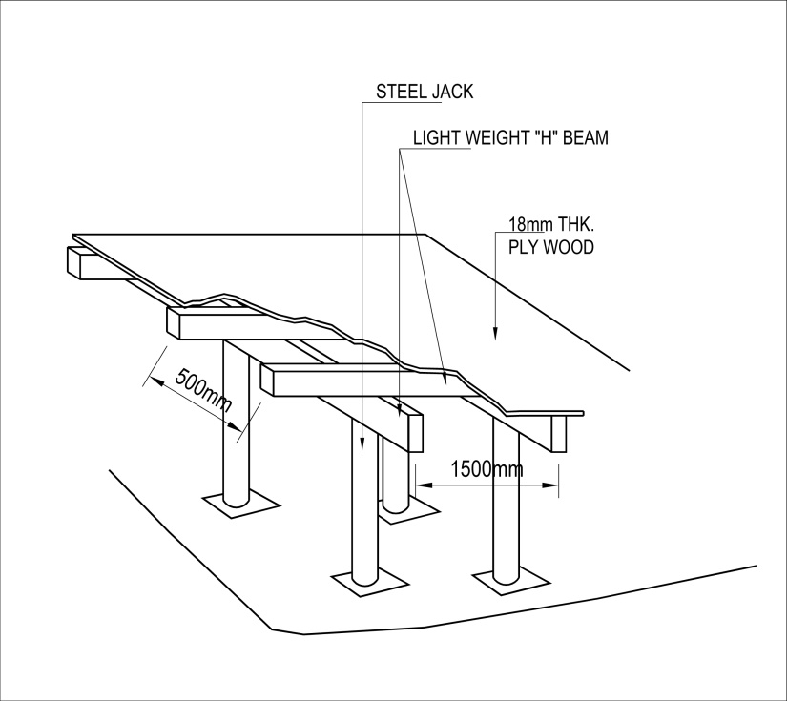

Fig. 06

Roof slab shutter should be levelled & braced with GI pipes. Later reinforcement to be laid (together with ledge beam)as per the bar schedule & leaving down pipe sleeves. And after the approvals of reinforcement, form work , left openings & walls/ columns surfaces should be free from broken partials/dust to receive C35A concrete to required levels shown in drawings and follow the No. 11 for cubes casting & curing. Concrete Pouring pattern & Schedule of time shown Fig. 07 & Fig. 08 below.

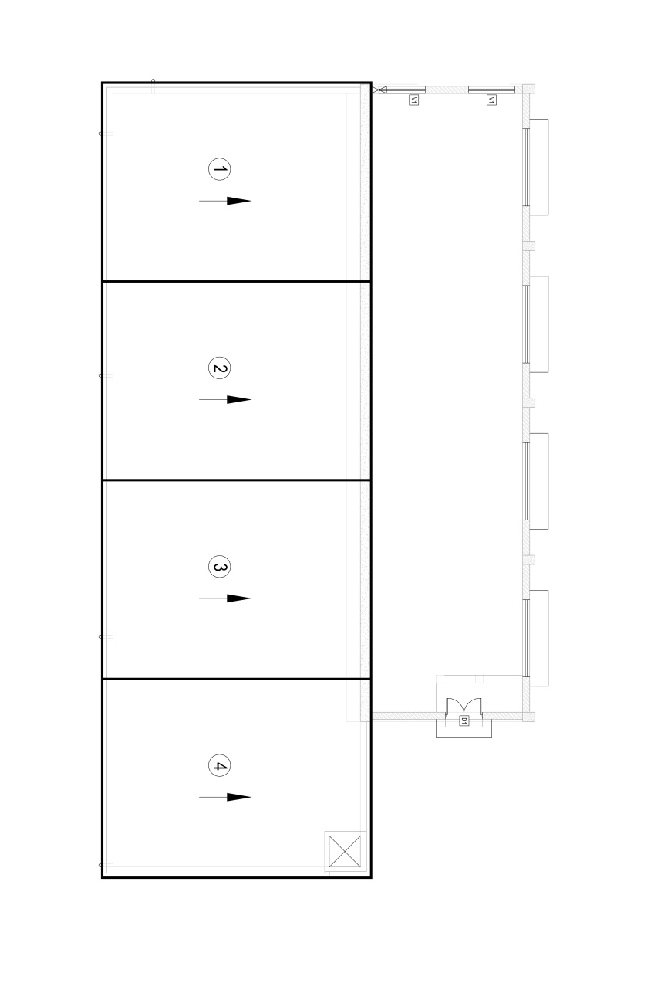

Fig. 07 Concrete Pouring Pattern

|  |  |  |  |  |
| --- | --- | --- | --- | --- |
| Truck No. | Volume(m3) | Batching Time | Arrival at Site | Concrete Finish Time |
| 01 | 5 | 9.00 | 9.45 | 10.15 |
| 02 | 5 | 9.15 | 10.00 | 10.45 |
| 03 | 5 | 9.30 | 10.15 | 11.15 |
| 04 | 5 | 9.45 | 10.30 | 11.45 |
| 05 | 5 | 10.00 | 10.45 | 12.15 |
| 06 | 5 | 10.15 | 11.00 | 12.45 |
| 07 | 5 | 10.30 | 11.15 | 13.15 |
| 08 | 5 | 10.45 | 11.30 | 13.45 |
| 09 | 5 | 11.00 | 11.45 | 14.15 |
| 10 | 5 | 11.15 | 12.00 | 14.45 |

Fig. 08. Concrete volume & Time Schedule

**Pump Room Roof Construction**

1. Roof beam will be casted (RB1 & RB2) at 148.56 also Portal beam as per the drawings.

Roof is covering by Zinc aluminium roof covering with the insulation foil as per given drawings.

**Brick & Plastering works**

1. Burn clay bricks 215x102.5x65 mm in size shall be used for construction of pump room walls as per the drawings by cement : sand ratio 1:5, leaving necessary openings for the windows, doors up to bottom level of lintels ie. 147.600. Simultaneously columns to be casted to same level.
2. At the level of 147.600, lintel (LB01 & LB02) reinforcement / form work should be get approved and C25 grade concrete to be done, All columns should be casted to the 146.800 level with brick works. after the necessary approvals.
3. 20mm thick plaster shall be carried out in side & out side of the walls with cement : sand ratio 1:5.

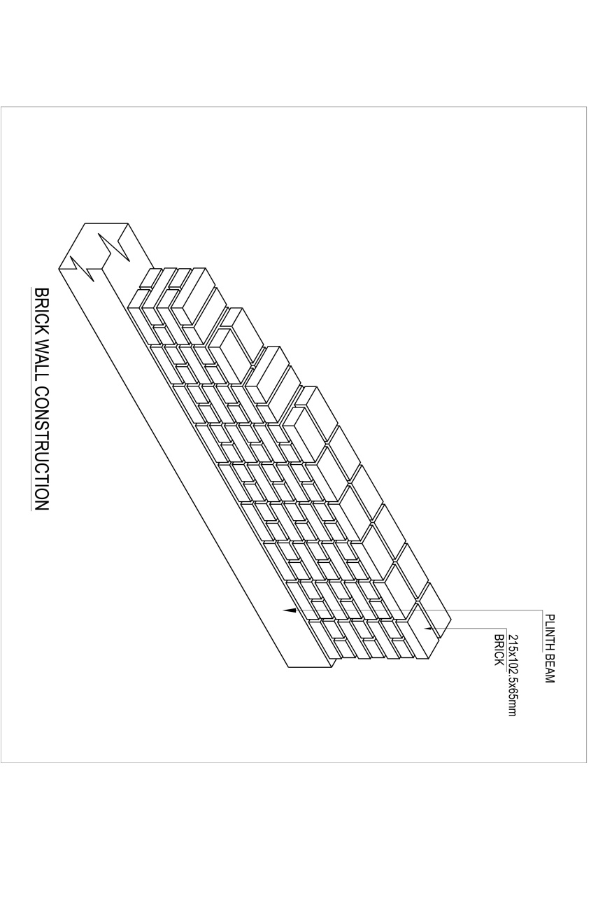

**6.1. Concrete Repair Works**

If any concrete repairs will exist, that is to be carried out by after getting the approval of the respective method statement.

**6.2. CONCRETE TESTING**

Sampling and testing of fresh and hardened concrete will be carried out in accordance with the provisions of BS 1881.

**7. HSE During Construction**

BS OHSAS 18001: 2007 (Occupational Health & Safety Management System,

Labour Code of Sri Lanka - 2010, Ministry of Labour & productivity Promotion, Sri Lanka)

specified requirements for an OH&S management system will be adopted during all the site work.