TABLE OF CONTENTS



1

. INTRODUCTION



................................

................................

................................

................................

............



2



1. REFERENCE DOCUMENTS…………………………………………………………………………………………2

1. PLANT & MACHINERIES…… ……………………………………………………………………………2

1. WORK DESCRIPTION …………………………………………………………………………………...3

1. CONSTRUCTION WORKS ……………………………………………………………………. 3-8

1. SEQUENCE OF CONSTRUCTION ……………………………………… 8-21

1. HSE ...................................... ………………..………………………………………………………………21

# 1. INTRODUCTION

This document consists of the details methodology and work plan of construction of 1500m³ Tower at Pothuhera.

Construction of 1500m³ consist of external stair case with following elements

* There are 32 Nos Footings (F1-1300, F2-1450, F3-1600 & F4-1250) sitting on the bed rock with the 20mm dia. Rock anchor rods drill into the bed rock at 2m depth.
* There are 14 Nos. C1,C4,C6,C8 and C10 type circular column, 2 Nos each

C2 & C9 type Square column, 4 Nos each C3 & C7, Square column, 4 Nos

C5, Square columns constructing with the tie beams (B01 to B13)

* 22.8m dia. 400mm thick,. tank base at 165.00 MSL
* 350mm circular tank wall constructing upto 169.3 MSL
* 250mm cover slab constructing with the 16Nos columns (400mm square) and column heads (1600mm square) supports
* Construction of access manhole & air vent chamber and staircase
* Fixing of inlet, outlet, over flow and washout DI pipes with DI valves
* Placing of Stainless steel (316) ladder, aluminium chequered plate and DI manhole covers.
* Landscaping of site

# 2. REFERENCE DOCUMENTS

All related Contract Specification in the contract document shall be followed relevant to scope of work.

GFC Drawings, Approved Typical details etc.

# 3. PLANT & MACHINERIES

* Truck / Tipper
* Concrete Transit Mixer (From RMC Supplier)
* Mobile concrete Pump
* Water Bowser
* Levelling Instrument/Total Station
* Thermometers
* Slump cone and test mould
* Porker Vibrator
* Scaffolding / Staging Materials
* Rock driller with air compressor
* Water Pumps...etc

# 4. DESCRIPTION OF WORK

The work described above shall consist of the excavation work, rebar work, formwork, Ready mix concrete, fixing of pipe fittings and accessories, protective paint and backfilling & compaction. Other than that this method statement covers the assuring quality of construction, material and relevant safety measures adopted during construction.

# 5. CONSTRUCTION WORKS

**5.1. EARTH WORKS**

## 5.1.1 Survey Works

1. Initially Temporary Bench Mark (TBM) will be established in the Pothuhera Tower site from fixed/known TBM which is allocated by the employer’s representative.

1. The professional surveyor shall be engaged to transfer the level datum and two primary mark will be established in Pothuhera siteite.

1. Two pillars will be constructed at the site to establish the levels and mark shall be coloured with red or yellow.

1. All setting-out should be done and get it approved before starting from the main contractor/ client

## 5.1.2 Excavation Works

**5.1.2.1 Excavation in the soft/hard soil & Rock.**

1. Earth work of structures shall be in accordance with BS 8004.
2. The Footing locations to be excavated (upto rock ) shall be cleared off all debris, bushes, logs, stumps and all objectionable material and disposed of as per the location finalized. Furthermore, safety precaution will be arranged to prevent the damage by rolling of rocks or sliding of soil during excavation and construction period.

1. Bed Rock in the footing location to be excavated up to level surface (Plat surface).

1. As far as possible all excavation shall be carried out using mechanical excavators. Wherever, the excavation quantities are minimal or the limited space for mechanical excavation, manual excavation shall be carried out.

1. It shall always be ensured that the excavation is carried out to the true line alignment and levels conforming to the approved drawing.

1. The excavated earth shall be stacked at a safe distance.

1. Any accumulation of water in the pit shall be dewatered without affecting other working areas and the slush underneath shall be cleaned before casting of PCC/ level concrete.

1. It shall be ensured that the minimum dimension required (Working space) from criterion of providing formwork, safety and ease of working as defined in the safety manual are adhered to.

1. Finally, excavated hard rock surface should be inspected by experience geologist to make sure that loose materials are removed, as per the soil investigation report.

### 5.1.3. Backfilling Works

1. Back filling shall be carried out using selected excavated soil/ materials approved by the Engineer.

1. Backfilling earth shall be free from debris, rock particles and building materials.

1. Any loose material, protrusions, formwork components shall be cleared before commencement of backfill. The excess area between the natural ground and external wall faces shall be backfilled in layers not exceeding 150 mm after proper ramming using plate compactors, watering and consolidation. The final backfill surfaces shall be maintained to a proper profile and level as per the requirement. The compaction shall be tested (Achieve compaction not less than 95% MDD for each layer) as per contract specifications.

1. The gap between footing and rock should be filled by grade 20 concrete to prevent water stagnation.

## 5.2. REINFORCEMENT

1. Reinforcement bar shall be hot rolled weldable deformed steel bars confirming to BS standard.

1. The shop drawing with bar schedule shall be submitted to client representative for approval prior to bending of reinforcement. Bar bending schedule shall incorporate the bar lengths, hook sizes, overlap lengths, spacer bars, bar diameter, crank spacing etc.

1. Reinforcement shall be accurately fabricated to the dimensions indicated in the drawings. The cutting and bending of reinforcement bars will be carried out using a cutting/ bending machine or manually and as per the bar bending schedules.

1. Before being placed in position reinforcement shall be thoroughly cleaned of rust, dirt, grease, paint or other coatings.

1. The erected reinforcement shall be secured with iron wire ties at inter section against displacement

1. Sufficient number of cover blocks and stools shall be provided to hold the position of the reinforcement.

1. After the erection of reinforcement approval will be obtained from client to erect the formwork.

1. Appropriate Concrete cover shall be maintained between reinforcement and face of concrete.

1. The straightening and re-bending of an incorrectly bent bar shall be avoided (re-bending work shall not be carried out). The straightening of the dowels wherever applicable shall be undertaken with proper care.

1. The reinforcement shall be placed as per the approved construction drawings and bar bending schedules given due consideration to the cover blocks, binding wires, chairs, curtailment, correctness of tolerances, hook specifications etc.

1. The insert plates, conduits, sleeves, anchors, opening etc. shall be suitably provided by welding / binding wire.

1. Under certain circumstances if necessary Re-baring of reinforcement will be adopted. The chemical anchoring will done for anchoring purposes with approval of the main contractor/ client.

## 5.4. FORMWORKS

1. The size of members of frame and support shall be adequately selected.

1. Formwork design details along with relevant shop drawings need to be submitted client representative approval (if necessary). 2x4 timber and the 18mm coated plywood with vertical support will be used for the form work.

1. The formwork shall be designed to withstand lateral thrust and weight of fresh concrete during vibration without distortion, leakage, cracking, failure and buckling.

1. The shutters shall be erected in proper line and level and shall be cross checked before put to implementation. Any old concrete droppings, protrusions, wooden dust, etc., before concreting shall be cleared off and the same shall be cleaned before installation.

1. The faces of formwork in direct contact with concrete shall be applied with a coat of approved mould oil.

1. All leakages, bulging, sagging, twisting and warping of formworks shall be avoided. However, in case of leakages, if any, tightening wedges adjustment by jacking and then approved methods shall be adopted before initial set of concrete.

1. The joints between each form work set shall be firmly sealed by sponge slips and masking tapes in order to prevent the grout leakage.

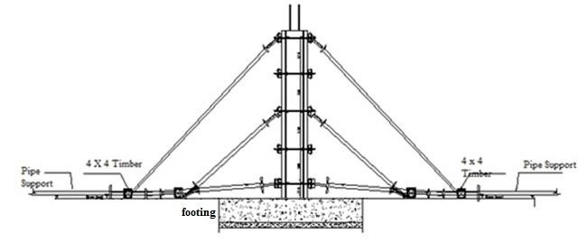

Fig 01 -Typical arrangement for column form work

## 5.5. STAGING /SCAFFOLDING

1. Scaffolding shall be adequately planned to cover the area of shuttering and to withstand the dead loads wherever applicable.

1. The vertical posts shall not be generally allowed to rest on the ground directly. The base plates of suitable thickness shall be provided below the props. If props are at rock area, scaffolding legs/ supports need to anchor with dowel to the rock. Wherever the area of shuttering details limits the provision of base plates, the same shall be allowed to rest on hard and compacted ground.

1. For all working platforms erected at any height greater than 6.0 m, two number working platforms shall be erected as an additional safety measure. Suitable temporary handrails shall be provided on all edges of working platform.

1. The staging shall be braced with diagonals, ropes, shears bracers as applicable to provide lateral stability against overturning and side thrust due to impact load, wind load, etc.

1. Safety tags to be attached on the staging/ scaffoldings by the Safety officer. To be used only after safety tagging.

1. Working platform should be much as far it can withstand the load of the number of workers working at the same time with necessary equipment like vibrates ,finishing tools, arms, tackles etc. and ease to inspect also.

## 5.6. CONCRETING

1. Concrete shall be outsourced from approved RMC supplier and grade of concrete should be approved upon trial mix test and confirmation by client representative.

1. Ready Mix Concrete will be transported to site by Transit Mixers(TM) from the approved supplier.

1. All tests shall be conducted as per the relevant BS 1881codes of practice for fresh & hardened concrete.

1. Slump test shall be performed at Batching plant site and immediately before placing.

1. Adequate number of 15 cm x 15 cm x 15 cm concrete cubes shall be tested for 7 to 28 days strength in the site laboratory and report shall be submitted to employer’s representative for approval.

1. Relevant 7 days and 28 days test reports shall be submitted and maintained at site after approval for ready reference and check.

1. The pour card for reinforced concrete activity shall be filled at site and countersigned for approval by the Employer’s representative before commencement of pour.

1. All checks for major concreting shall be done on the preceding day of concrete.

1. All raw materials, adequate manpower and relevant plant and machinery shall be kept ready for any exigency / emergency during concrete pour.

1. The concrete shall be poured within initial setting time of cement. It shall be ensured that initial set / segregation of concrete is avoided under all circumstances during transfer and placing.

1. The vertical drop chutes / elephant trunks shall be used to pour concrete at lower levels when the drop of concrete exceeds 1.5 m to avoid segregation

1. The immersion type needle vibrator size 60/40/20 shall be applied for compaction of concrete symmetrically to cover all areas immediately after placing of concrete. The vibrator needle shall penetrate vertically and vibration shall continue till concrete flattens, rising of air bubbles is terminated, concrete takes a glistening appearance and aggregates blend with the surface. The vibrator shall be withdrawn slowly so that the holes are not created during its removal.

1. The concrete surface shall be smoothened with a wooden float or a trowel with pressure to give a finish similar to that of the rubbed down shuttered faces. The finish shall be continued till the concrete reaches its initial set.

1. It shall be ensured that all structural insert plates, base plates, puddle, pipe fittings, bolts etc. are adequately and suitably anchored as per the approved construction drawings before commencement of concrete.

1. In order to expedite and to facilitate the progress, opening of suitable size shall be provided as a provision for installing puddles etc. in future. After the puddles under this provision have been installed, the openings shall be grouted with concrete/ non-shrinking material as required to ensure the watertight structure.

1. Level concrete shall be cast as per the required level (Bottom level of footings).

1. During hot weather to prevent the cracking or crazing of concrete shall arrange for concrete to be placed in the early morning or late evening as directed by the Engineer.

1. Concreting will not be permitted during heavy rain or when the concrete temperature rises above 30oC.

## 5.7. CURING

1. Curing shall be carried out using approved water source.

1. Curing shall be carried out based on the procedures given below. One or more of the prescribed methods shall be adopted based on the site requirements.

1. Moist Gunny Bags

When continuous water spray is not possible due to various obstructions, work in progress in close proximity and heights, it is proposed to cover fresh concrete either by gunny bags or hessian cloth and these shall be kept moist by spraying water for not less than 10 days.

1. Ponding

Usually ponding shall be employed over slabs and rafts or where large area of structure is exposed horizontally.

1. Curing compound

Usually curing compound shall be used for footings, beams, columns and walls..etc where is not possible to ponding or laying gunny bags.

# 6. SEQUENCE OF CONSTRUCTION

## Excavation

1. The ground area shall be scrapped and cleared off all the debris and loose materials/ boulders to expose rock surface.
2. Bed Rock in the footing location to be excavated up to level surface (Plat surface) by control blasting.

1. Surveyor has to outline the structural area with NWSDB/Wabag, the required lines/edge of the structure shall be fixed using Theodolite/ Total station. The edge distance of footing centre shall be located on the Excavated Rock at four corners. The corners shall be diagonally checked to ensure the correct layout of the structure.

1. The centre line, foundation edge & footing locations of the structure shall be denoted on the Rock by means of pegs at uniform distance following with white mark.

1. The excavation shall be carried out using mechanical or manual methods based on the quantity of earthwork and the working area. During excavation necessary slops should be kept as per the issued drawings.

1. Rock excavation doing by using air compressor asper site condition.

1. Footings formation levels on the bed rock will be decided as per the shape of rock formation and the rock characteristics mentioned in the soil investigation report.

1. All footing formation level should be in accordance with the drawing and elevations shall be verified with NWSDb/Wabag representative after completion of excavation.

### Rock Anchoring

9. Rock Anchoring will be proceeded as per the given drawing. The hole dia is 32mm and depth is 2m. T20mm tor steel bar will be used to anchor in to the rock and master flor 810 will be used to filling the gap between hole and steel bar. (Filling material, anchoring bar diameter and anchoring depth have confirmed by seperate method statement for pullout test).

### Blinding Concrete/ Levelling concrete

1. The level concrete shall be laid as per the level indicated in the approved drawings. Before pouring the concrete, dowel locations should be verified and fixed properly. And excavated rock surface should cleaned of from dust and debris.
2. Grade 25 concrete will be used for the levelling concrete as RCC due to available of dowel rebar.

### Footing Concrete

1. Tower Footings outer lines should be marked on levelling concrete top by the surveyor and that should be approved by NWSDB/Wabag. Block wall/Timber form work shall be erected footing outer faces to the height of about **700**mm & 150 mm height plywood form for column kicker. As shown in Fig. 02

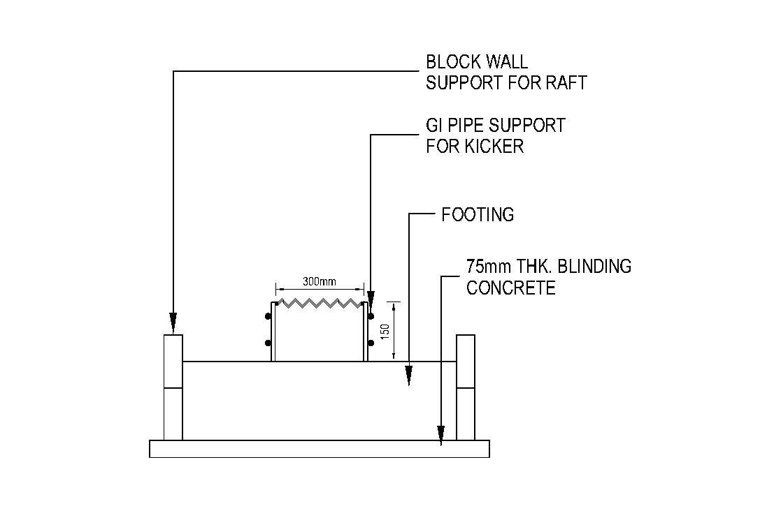

Levelling concrete

Fig. 02 – Footing and Kicker formwork

1. Footings & columns reinforcement shall be placed as per the approved drawing and bar schedule. All intersections of bars shall be secured with gauge 18 soft iron wire, the ends being turned into the body of the concrete. In the footing cover shall in earth face **75** mm and same as from top face **50**mm.
2. C25 grade concrete should be poured to footing & columns kicker using mobile concrete pump, after the approval of reinforcement & formwork.
3. While concerting pouring temperature to be maintained below 30 C , minimum 04 nos. of concrete cubes to be casted every 20m3 for 7 & 28 days testing.
4. After concreting, curing should be carried out by selected method in clause 5.7 in above and for 10 days from next day on wards.

The concrete for the footings is poured in sections, which are of a convenient size and volume to enable construction to be finished in the time available. The pouring volume and time taken for pouring are shown in the Table. 01

Table 01 - Concrete volume & Time Schedule

|  |  |  |  |  |
| --- | --- | --- | --- | --- |
| Truck No. | Volume (m3) | Batching Time | Arrival at Site | Concrete Finish Time |
| 01. | 4 | 8.00 | 8.45 | 9.30 |
| 02. | 4 | 8.15 | 9.00 | 9.45 |
| 03. | 4 | 8.30 | 9.15 | 10.00 |
| 04. | 4 | 8.45 | 9.30 | 10.15 |
| 05. | 4 | 9.00 | 9.45 | 10.30 |
| 06. | 4 | 9.15 | 10.00 | 10.45 |
| 07 | 4 | 9.30 | 10.15 | 11.00 |
| 08 | 4 | 9.45 | 10.30 | 11.15 |
| 09 | 4 | 10.00 | 10.45 | 11.30 |
| 10 | 4 | 10.15 | 11.00 | 11.45 |
| 11 | 4 | 10.30 | 11.15 | 12.00 |

44m3

### Columns / Tie Beams Concrete

1. Column 01st lift at slope area will be casted together with tie beams layout 01, as shown in Fig 03 after approvals for the reinforcement/formwork by NWSDB/Wabag. Grade C25 concreting to be carried out and follow the guideline for concrete cube casting & curing as in above.

The pouring volume and time taken for pouring are shown in the Table 02.

Table 02 - Concrete volume & Time Schedule

|  |  |  |  |  |
| --- | --- | --- | --- | --- |
| Truck No. | Volume (m3) | Batching Time | Arrival at Site | Concrete Finish Time |
| 01. | 3.5 | 8.00 | 8.45 | 9.30 |
| 02. | 3.5 | 8.15 | 9.00 | 9.45 |
| 03 | 3.5 | 8.30 | 9.15 | 10.00 |
| 04 | 3.5 | 8.45 | 9.30 | 10.15 |

14.00m3

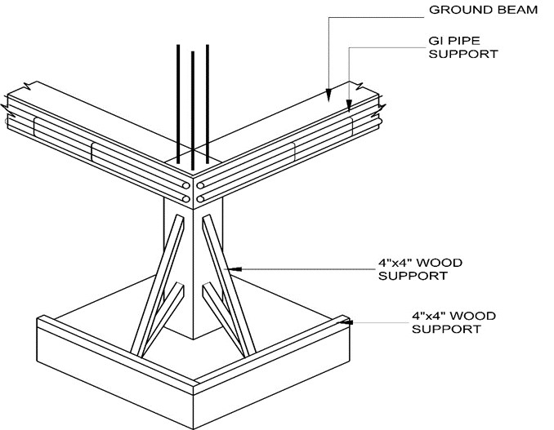

ACRO JACK

Fig. 03 – Column & Tie beam arrangement

1. Column 02nd lift and tie beam layout 02 & 03 will be casted together as shown above figure 03 after approvals for the reinforcement/formwork by NWSDB/Wabag Grade C25 concreting to be carried out and follow the guideline for concrete cube casting & curing as in above.

The pouring volume and time taken for pouring are shown in the table 03.

Table 03 - Concrete volume & Time Schedule

|  |  |  |  |  |
| --- | --- | --- | --- | --- |
| Truck No. | Volume (m3) | Batching Time | Arrival at Site | Concrete Finish Time |
| 01. | 4 | 8.00 | 8.45 | 9.30 |
| 02. | 4 | 8.15 | 9.00 | 9.45 |
| 03. | 4 | 8.30 | 9.15 | 10.00 |
| 04. | 4 | 8.45 | 9.30 | 10.15 |
| 05. | 4 | 9.00 | 9.45 | 10.30 |
| 06. | 4 | 9.15 | 10.00 | 10.45 |
| 07 | 4 | 9.30 | 10.15 | 11.00 |
| 08 | 4 | 9.45 | 10.30 | 11.15 |
| 09 | 4 | 10.00 | 10.45 | 11.30 |
| 10 | 4.5 | 10.15 | 11.00 | 11.45 |
| 11 | 4.5 | 10.30 | 11.15 | 12.00 |

45m3

1. Column 03rd lift and tie beam layout 04 will be casted together as shown above figure 03 after approvals for the reinforcement/formwork by NWSDB/Wabag. Grade C25 concreting to be carried out and follow the guideline for concrete cube casting & curing as in above.

The pouring volume and time taken for pouring are shown in the table 04

Table 04 - Concrete volume & Time Schedule

|  |  |  |  |  |
| --- | --- | --- | --- | --- |
| Truck No. | Volume (m3) | Batching Time | Arrival at Site | Concrete Finish Time |
| 01. | 4 | 8.00 | 8.45 | 9.30 |
| 02. | 4 | 8.15 | 9.00 | 9.45 |
| 03. | 4 | 8.30 | 9.15 | 10.00 |
| 04. | 4 | 8.45 | 9.30 | 10.15 |
| 05. | 4 | 9.00 | 9.45 | 10.30 |
| 06. | 2 | 9.15 | 10.00 | 10.45 |

22.0 m3

1. Formwork and scaffolding arrangement for columns shall be followed as shown figure 04, in bellow

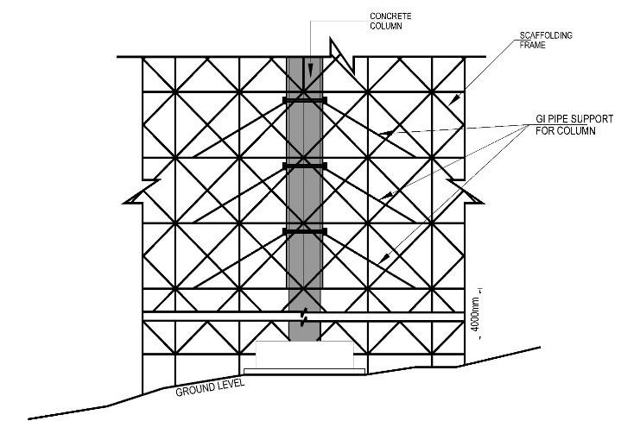

Fig. 04 Formwork & Scaffolding arrangement for columns

### Tank base slab and beam concrete

1. Tank base beams (TB01 to TB06) and tank base slab (400mm thick and Dia 22.8m) will be finished at 165.00MSL. At the same time tank wall kicker should be casted together as shown in Fig. 05 after the approvals for the reinforcement/ formwork by NWSDB/Wabag. Grade C35A concreting to be carried out and follow the guideline for concrete cube casting & curing as in above. Pouring pattern shown in Fig.

06.

After pouring of the wall kicker concrete, the green cut will be performed as per approved method to get proper rough surface for next wall step.

The pouring volume and time taken for pouring are shown in the table 05..

Table 05 - Concrete volume & Time Schedule

|  |  |  |  |  |
| --- | --- | --- | --- | --- |
| Truck No. | Volume (m3) | Batching Time | Arrival at Site | Concrete Finish Time |
| 01. | 4 | 4.00 PM | 4.45 PM | 5.15 PM |
| 02. | 4 | 4.15 | 5.00 | 5.30 |
| 03. | 4 | 4.30 | 5.15 | 5.45 |
| 04. | 4 | 4.45 | 5.30 | 6.00 |
| 05. | 4 | 5.00 | 5.45 | 6.15 |
| 06. | 4 | 5.15 | 6.00 | 6.30 |
| 07 | 4 | 5.30 | 6.15 | 6.45 |
| 08 | 4 | 5.45 | 6.30 | 7.00 |
| 09 | 4 | 6.00 | 6.45 | 7.15 |
| 10 | 4 | 6.15 | 7.00 | 7.30 |
| 11 | 4 | 6.30 | 7.15 | 7.45 |
| 12 | 4 | 6.45 | 7.30 | 8.00 |
| 13 | 4 | 7.00 | 7.45 | 8.15 |
| 14 | 4 | 7.15 | 8.00 | 8.30 |
| 15 | 4 | 7.30 | 8.15 | 8.45 |
| 16 | 4 | 7.45 | 8.30 | 9.00 |
| 17 | 4 | 8.00 | 8.45 | 9.15 |
| 18 | 4 | 8.15 | 9.00 | 9.30 |
| 19 | 4 | 8.30 | 9.15 | 9.45 |
| 20 | 4 | 8.45 | 9.30 | 10.00 |
| 21 | 4 | 9.00 | 9.45 | 10.15 |
| 22 | 4 | 9.15 | 10.00 | 10.30 |
| 23 | 4 | 9.30 | 10.15 | 10.45 |
| 24 | 4 | 9.45 | 10.30 | 11.00 |
| 25 | 4 | 10.00 | 10.45 | 11.15 |
| 26 | 4 | 10.15 | 11.00 | 11.30 |
| 27 | 4 | 10.30 | 11.15 | 11.45 |
| 28 | 4 | 10.45 | 11.30 | 12.00 |
| 29 | 4 | 11.00 | 11.45 | 12.15 |
| 30 | 4 | 11.15 | 12.00 | 12.30 |
| 31 | 4 | 11.30 | 12.15 | 12.45 |
| 32 | 4 | 11.45 | 12.30 | 1.00 |
| 33 | 4 | 12.00 | 12.45 | 1.15 |
| 34 | 4 | 12.15 | 1.00 | 1.30 |
| 35 | 4 | 12.30 | 1.15 | 1.45 |
| 36 | 4 | 12.45 | 1.30 | 2.00 |
| 37 | 4 | 1.00 | 1.45 | 2.15 |
| 38 | 4 | 1.15 | 2.00 | 2.30 |
| 39 | 4 | 1.30 | 2.15 | 2.45 |
| 40 | 4 | 1.45 | 2.30 | 3.00 |
| 41 | 4 | 2.00 | 2.45 | 3.15 |
| 42 | 4 | 2.15 | 3.00 | 3.30 |
| 43 | 4 | 2.30 | 3.15 | 3.45 |
| 44 | 4 | 2.45 | 3.30 | 4.00 |
| 45 | 4 | 3.00 | 3.45 | 4.15 |
| 46 | 4 | 3.15 | 4.00 | 4.30 |
| 47 | 4.5 | 3.30 | 4.15 | 4.45 |
| 48 | 4.5 | 3.45 | 4.30 | 5.00 |
| 49 | 4.5 | 4.00 | 4.45 | 5.15 |
| 50 | 4.5 | 4.15 | 5.00 | 5.30 |

202.00m3

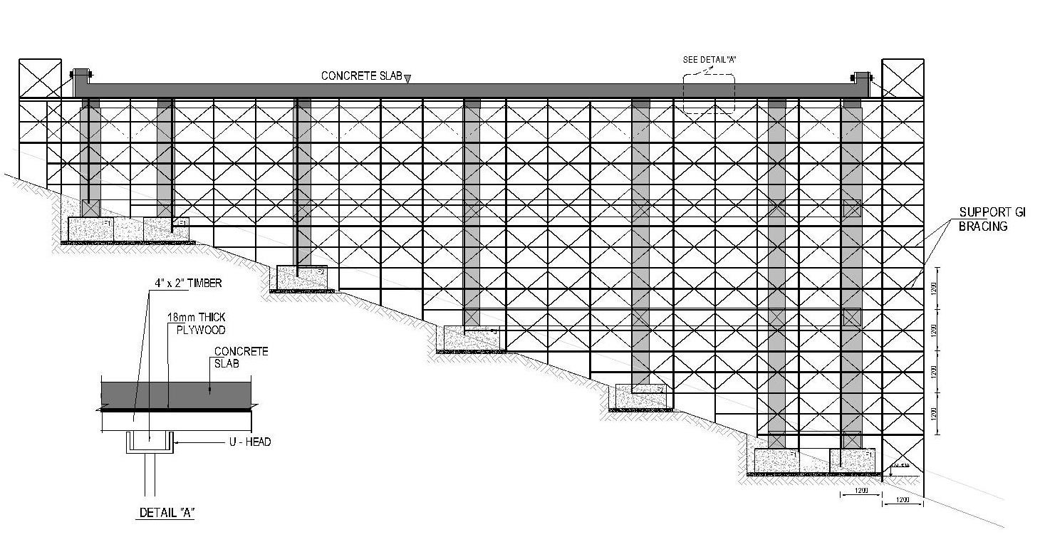

Fig

05

. Scaffolding arrangement

& Wall Kicker

for Tank

base slab



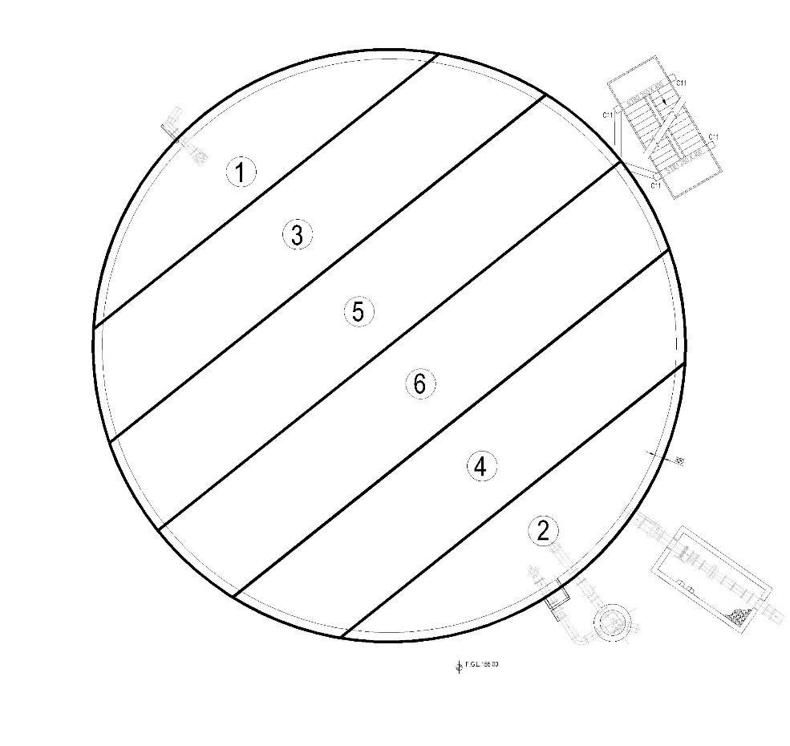

Fig 06. Concrete Poring Pattern – Tank Base Slab

**Tank Wall Concrete**

1. The wall reinforcement shall be erected in correct spacing as per the approved drawing and shall be placed vertical to the plumb as far as possible. The spacing of the reinforcement shall be checked before concreting. Vertical bars shall be supported properly during raft slab concreting and further works.

1. Wall shutters will be fixed in to two steps. 01st lift height is 2.2m and 02nd lift is 1.9m, where up to wall top level. Formwork shall be positioned side of the kicker/ wall joint and appropriate inner supports will be placed. After cleaning of particles in the existing wall outer shutter will be continued and both shutters properly tightened with combination of ‘P’ cones and tie rods. Before close the formwork, approval to be taken for existing surface is in satisfactory condition for rough surface after green cutting. Wall shutters shall be erected to plumb and wall width of 350mm maintained. All puddle shall be installed while fixing formwork and casting together with wall concrete.

1. The foam of required thickness shall be provided in between the adjoining shutters and along the wall face to prevent the leakage of the slurry. All subsequent lifts of the walls shall be cast using adequate staging, platform, and alignment and placing the shutters as discussed above. In case of any leakage of slurry, the same shall be washed off with jet of water to prevent the setting of concrete on the wall surface.

1. Tank wall (r-11.4m) & 16 Nos tank columns (4m) should be casted together as shown in Fig. 07 after the approvals for the reinforcement/formwork by NWSDB/Wabag grade C35A concreting to be carried out and follow the guideline for concrete cube casting & curing as in above.

The pouring volume and time taken for pouring are shown in the Table 06.

Table 06 - Concrete volume & Time Schedule for wall 01st lift

|  |  |  |  |  |
| --- | --- | --- | --- | --- |
| Truck No. | Volume (m3) | Batching Time | Arrival at Site | Concrete Finish Time |
| 01. | 4 | 4.00 PM | 4.45 PM | 5.15 PM |
| 02. | 4 | 4.15 | 5.00 | 5.30 |
| 03. | 4 | 4.30 | 5.15 | 5.45 |
| 04. | 4 | 4.45 | 5.30 | 6.00 |
| 05. | 4 | 5.00 | 5.45 | 6.15 |
| 06. | 4 | 5.15 | 6.00 | 6.30 |
| 07 | 4 | 5.30 | 6.15 | 6.45 |
| 08 | 4 | 5.45 | 6.30 | 7.00 |
| 09 | 4 | 6.00 | 6.45 | 7.15 |
| 10 | 4 | 6.15 | 7.00 | 7.30 |
| 11 | 4 | 6.30 | 7.15 | 7.45 |
| 12 | 4 | 6.45 | 7.30 | 8.00 |
| 13 | 4 | 7.00 | 7.45 | 8.15 |
| 14 | 4 | 7.15 | 8.00 | 8.30 |
| 15 | 4 | 7.30 | 8.15 | 8.45 |

60.00m3

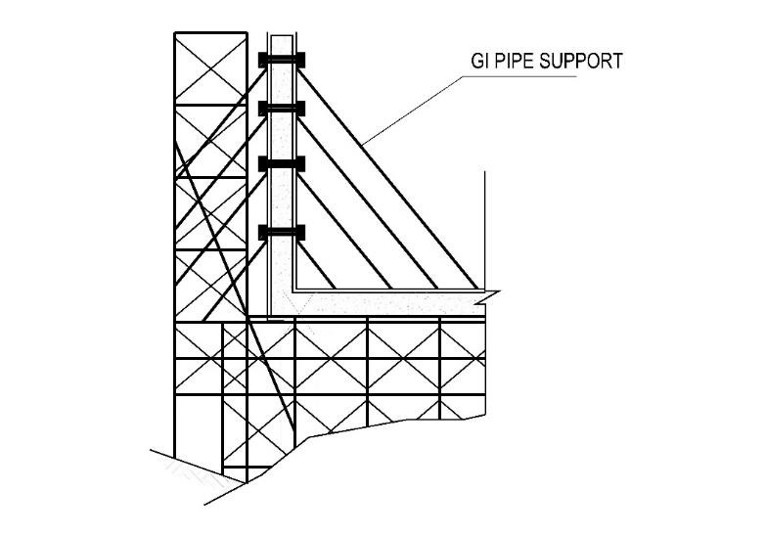

Fig. 07 Scaffolding arrangement for Tank Wall.

Table 07 - Concrete volume & Time Schedule for wall 02nd lift

|  |  |  |  |  |
| --- | --- | --- | --- | --- |
| Truck No. | Volume (m3) | Batching Time | Arrival at Site | Concrete Finish Time |
| 01. | 4 | 4.00 PM | 4.45 PM | 5.15 PM |
| 02. | 4 | 4.15 | 5.00 | 5.30 |
| 03. | 4 | 4.30 | 5.15 | 5.45 |
| 04. | 4 | 4.45 | 5.30 | 6.00 |
| 05. | 4 | 5.00 | 5.45 | 6.15 |
| 06. | 4 | 5.15 | 6.00 | 6.30 |
| 07 | 4 | 5.30 | 6.15 | 6.45 |
| 08 | 4 | 5.45 | 6.30 | 7.00 |
| 09 | 4 | 6.00 | 6.45 | 7.15 |
| 10 | 4 | 6.15 | 7.00 | 7.30 |
| 11 | 4 | 6.30 | 7.15 | 7.45 |
| 12 | 4 | 6.45 | 7.30 | 8.00 |
| 13 | 4 | 7.00 | 7.45 | 8.15 |

52.00m3

**Tank Roof Slab Concrete**

1. 250mm thk. Tank roof slab should be casted together with the 16 Nos tank columns head after the approvals for the reinforcement/formwork, cleaning of column top surface by NWSDB/Wabag. Grade C35A concreting to be carried out and follow the guideline for concrete cube casting & curing as in above.
2. Wall tops should be free from broken partials/dust and that should be levelled to 169.300MSL. Bofore start rebar laying work, approval to be taken for slip membrane, which has laid and pase on wall top surface. Roof slab shutter & reinforcement shall be arranged as shown in Fig. 08 below, box outing for air vent /man holes. After the approvals of reinforcement ,form work & keeping required openings for air vent / man holes, C35 A concrete to be poured & level to the required slope maintain pouring temperature below 30 0C and pouring pattern as shown in fig 09.

Curing of slab shall be followed the wet gunny bags and as per the description given in the item No 5.7. Removal of shutter shall be accordance with technical specifications and approval with the Engineer’s approval.

The surface of the P-Cone holes shall be well cleaned and rough for dry pack mortar to free from dust and other loose material. On the saturated surface construction grout (non- shrinkage) shall be applied as per the manufactures specification. Then the repaired surface will be cured for 24 Hrs.

The pouring volume and time taken for pouring are shown in the table 08.

.

Table 08 - Concrete volume & Time Schedule

|  |  |  |  |  |
| --- | --- | --- | --- | --- |
| Truck No. | Volume (m3) | Batching Time | Arrival at Site | Concrete Finish Time |
| 01. | 4 | 4.00 PM | 4.45 PM | 5.15 PM |
| 02. | 4 | 4.15 | 5.00 | 5.30 |
| 03. | 4 | 4.30 | 5.15 | 5.45 |
| 04. | 4 | 4.45 | 5.30 | 6.00 |
| 05. | 4 | 5.00 | 5.45 | 6.15 |
| 06. | 4 | 5.15 | 6.00 | 6.30 |
| 07 | 4 | 5.30 | 6.15 | 6.45 |
| 08 | 4 | 5.45 | 6.30 | 7.00 |
| 09 | 4 | 6.00 | 6.45 | 7.15 |
| 10 | 4 | 6.15 | 7.00 | 7.30 |
| 11 | 4 | 6.30 | 7.15 | 7.45 |
| 12 | 4 | 6.45 | 7.30 | 8.00 |
| 13 | 4 | 7.00 | 7.45 | 8.15 |
| 14 | 4 | 7.15 | 8.00 | 8.30 |
| 15 | 4 | 7.30 | 8.15 | 8.45 |
| 16 | 4 | 7.45 | 8.30 | 9.00 |
| 17 | 4 | 8.00 | 8.45 | 9.15 |
| 18 | 4 | 8.15 | 9.00 | 9.30 |
| 19 | 4 | 8.30 | 9.15 | 9.45 |
| 20 | 4 | 8.45 | 9.30 | 10.00 |
| 21 | 4 | 9.00 | 9.45 | 10.15 |
| 22 | 4 | 9.15 | 10.00 | 10.30 |
| 23 | 4 | 9.30 | 10.15 | 10.45 |
| 24 | 4 | 9.45 | 10.30 | 11.00 |
| 25 | 4 | 10.00 | 10.45 | 11.15 |
| 26 | 4 | 10.15 | 11.00 | 11.30 |
| 27 | 4 | 10.30 | 11.15 | 11.45 |

108m3

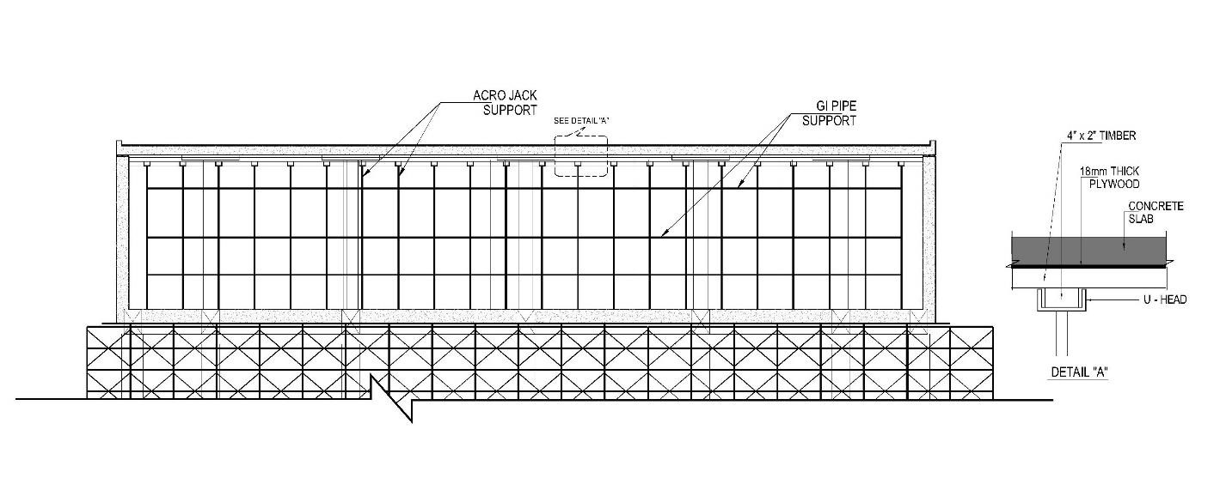

Fig. 08. Scaffolding arrangement for Tank Roof Slab.

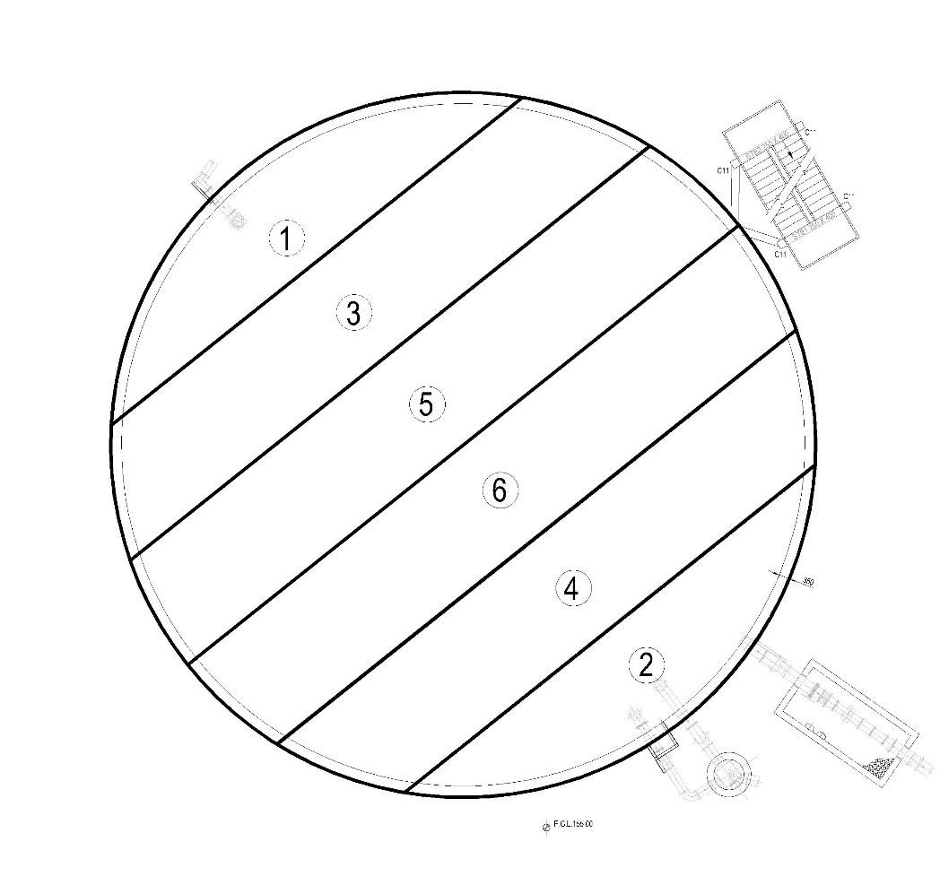

Fig. 09. Concrete poring Pattern for Tank Roof Slab

### Guard wall, Air ventilator wall/ slab and Manhole wall concrete

28. Guard wall, manhole wall and air ventilator wall/slab will be casted together after approvals for the reinforcement/formwork by NWSDB/Wabag. Grade C35A concreting to be carried out and follow the guideline for concrete cube casting & curing as in above.

The pouring volume and time taken for pouring are shown in the table 09

Table 09 - Concrete volume & Time Schedule

|  |  |  |  |  |
| --- | --- | --- | --- | --- |
| Truck No. | Volume (m3) | Batching Time | Arrival at Site | Concrete Finish Time |
| 01. | 3 | 4.00 PM | 4.45 PM | 5.15 PM |
| 02. | 3 | 4.15 | 5.00 | 5.30 |

06.0 m3

### External Staircase work

29. External stair case should be casted as per given drawing details with the Landings abd flights. Hand Rail at Stair case & Roof slab will be constructed as per approved drawings.

## Concrete Repair work

30. If any concrete repairs will exist, that is to be carried out by after getting the approval of the respective method statement as per the manufacture specification of repairing materials.

## Concrete Testing

31. Sampling and testing of fresh and hardened concrete will be carried out in accordance with the provisions of BS 1881.

## 07. HSE During construction

32. BS OHSAS 18001: 2007 (Occupational Health & Safety Management System,

Labour Code of Sri Lanka - 2010, Ministry of Labour & productivity Promotion, Sri Lanka) specified requirements for an OH&S management system will be adopted during all the site work.